Strength Training: Legs
Strengthen quads, glutes and hamstrings to help with walking and balance after surgery.
Do one exercise from LEGS A and one exercise from LEGS B.
LEVEL | LEGS A |  | LEGS B
Level  1 | Sit-to-stand with support  -Start seated in an armchair.  -Using as little assistance from your arms as possible, push up with your legs to stand.  -Reverse the movement by bending your knees slowly to sit back down  2 sets of 5-10 reps | 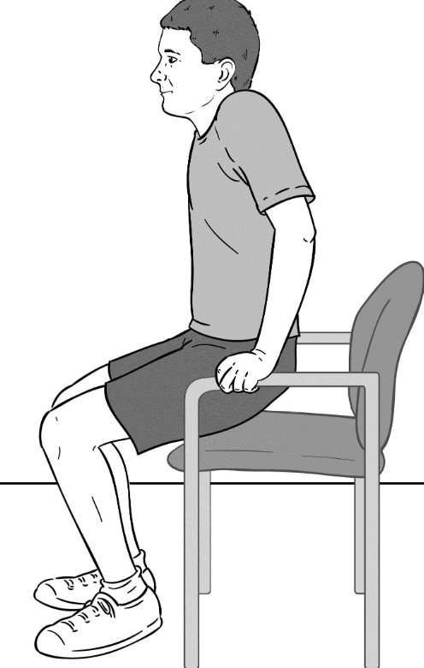 | Clamshell  -Lie on your side with bottom arm extended over head and top arm providing support.  -Bend knees (and hips?) to 90 degrees.  -Lift the top leg up.  -Slowly lower knee back to starting position.  2 sets of 10 reps on each side
Level 2 | Sit-to-stand without support  -Start seated and clasp hands together  -Push up with your legs to stand.  -Reverse the movement by bending your knees slowly to sit back down.  2 sets of 10-15 reps | 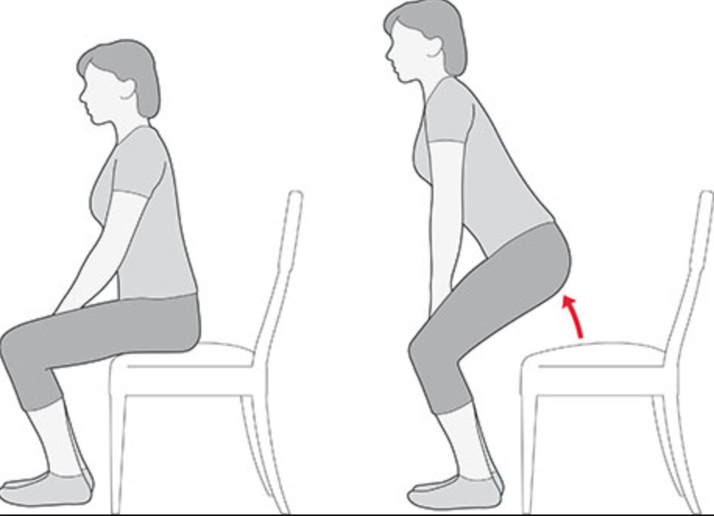 | Single leg abductor raise  -Lie on your side with bottom arm extended over head and top arm providing support.  - Lift top leg up.  -Slowly lower leg back to starting position.  2 sets of 10-15 reps on each side | 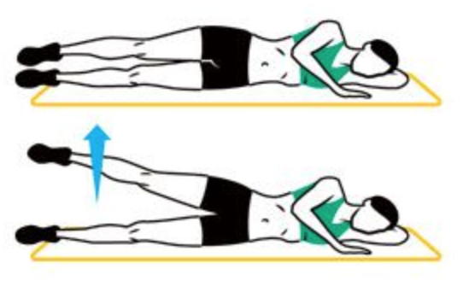
Level 3 | Half-squat  -Stand with feet hip-distance apart, toes slightly pointed outward.  -Bend knees to 45 degrees, keeping kneecaps in line with toes.  -As you straighten legs, squeeze glutes.  3 sets of 10-15 reps |  | Step-ups  -Find a step, no higher than your knee.  -Place one foot on the step. Straighten leg on step while pressing off with back foot to bring both feet to step.  -Step down one foot at a time.  3 sets of 15 reps on each side
Level 4 | Squat  -Stand with feet hip-distance apart, toes slightly pointed outward.  -Bend knees to 90 degrees, keeping kneecaps in line with toes.  -As you straighten legs, squeeze glutes.  3 sets of 10 reps |  | Static Lunge  -Start standing.  -Step one foot forward 2-3 feet in front of you.  -Bend both knees until front knee is over foot and back knee hovers over ground.  -Push back to the starting position.  3 sets of 10 reps on each side
Strength Training: Arms
Strengthen your chest, triceps, and back to help you get out of bed and do everyday activities.
Do one exercise from ARMS A and one exercise from ARMS B.
LEVEL | ARMS A |  | ARMS B
Level  1 | Push-up on wall  -Place palms against wall, slightly wider than shoulder-width apart.  -Back feet a couple feet away from wall. Keeping back straight, slowly bend elbows to bring your upper body towards wall.  -Push back to starting position  2 sets of 5-10 reps |  | Wall angels  -Stand with back against wall.  -Bend arms to 90 degrees, keeping elbows and wrists touching wall.  -While keeping contact with wall, slowly raise hands straight up. Slowly bring arms back to 90 degrees.  2 sets of 10-15 reps | 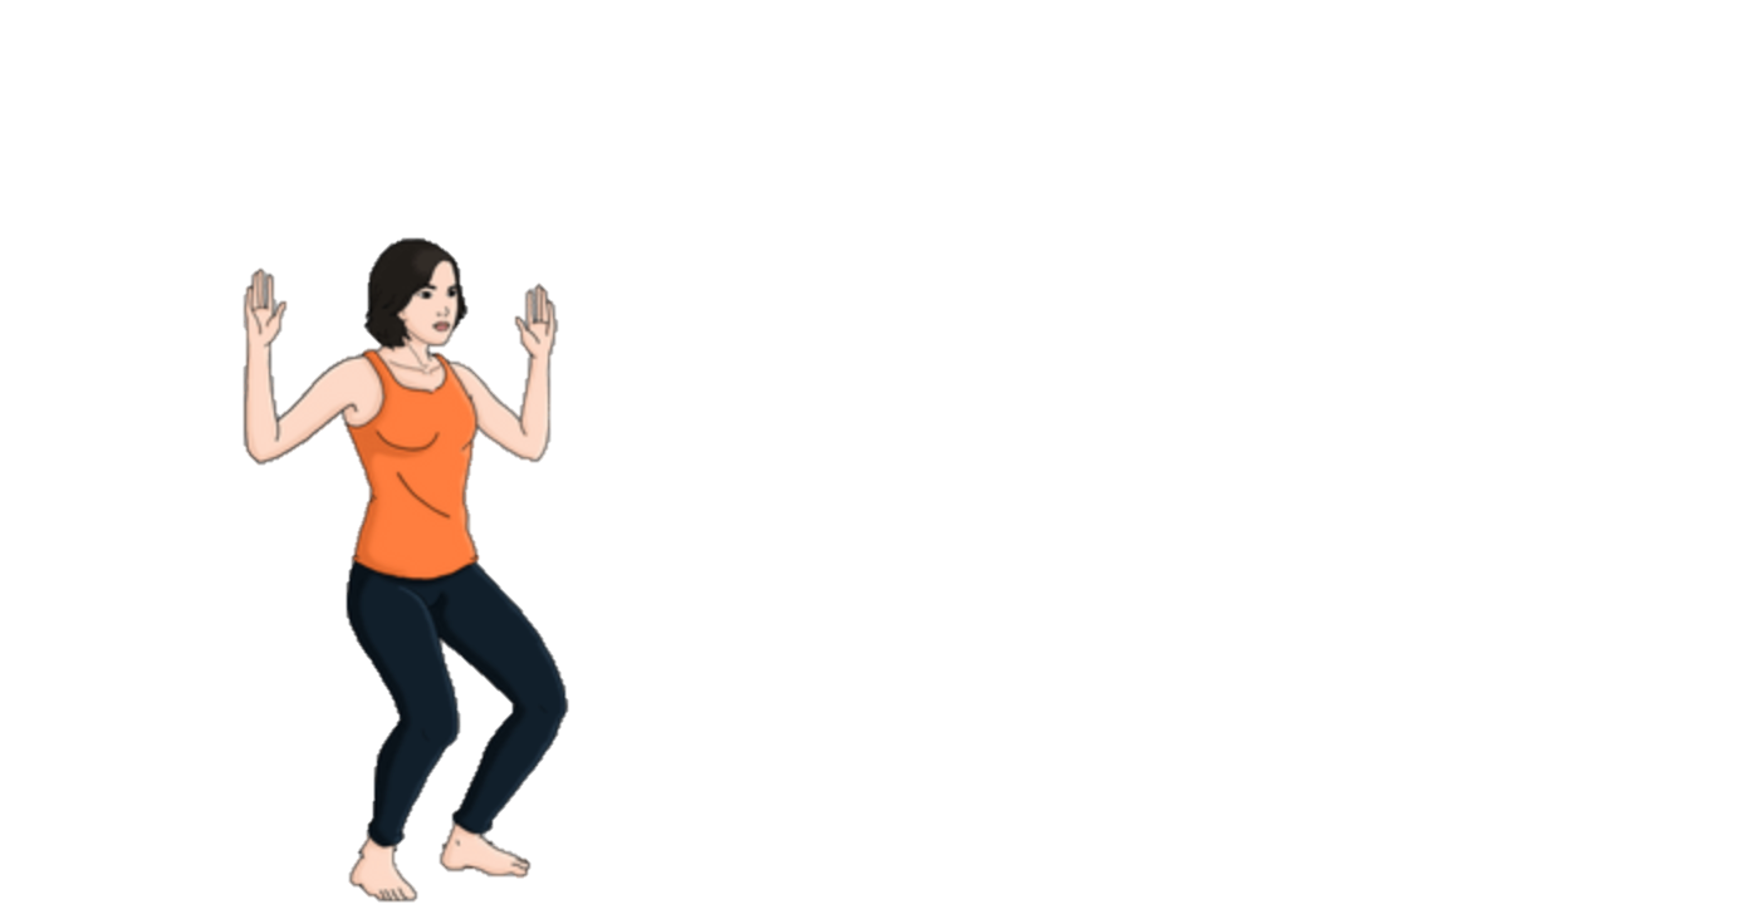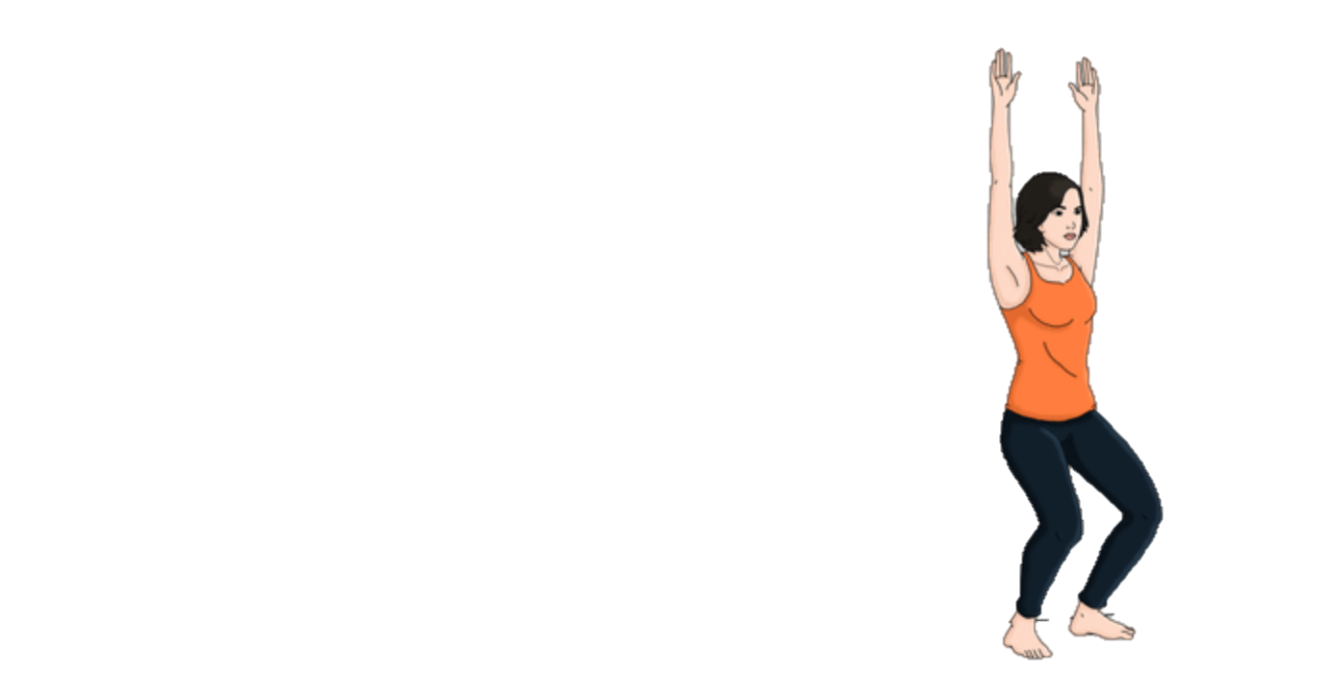
Level 2 | Push-up on knees  -Start with palms on the floor underneath shoulders, hips straight, and knees on the floor  -Slowly bend elbows out to side, lowering until just above floor.  -Push back up.  3 sets of 5-10 reps |  | Arm circles  -Stand with arms extended straight outwards  -Move arms in small, fast circles forward.  -Then move arms in reverse direction.  As many reps as possible in forward and reverse direction; 3 sets | 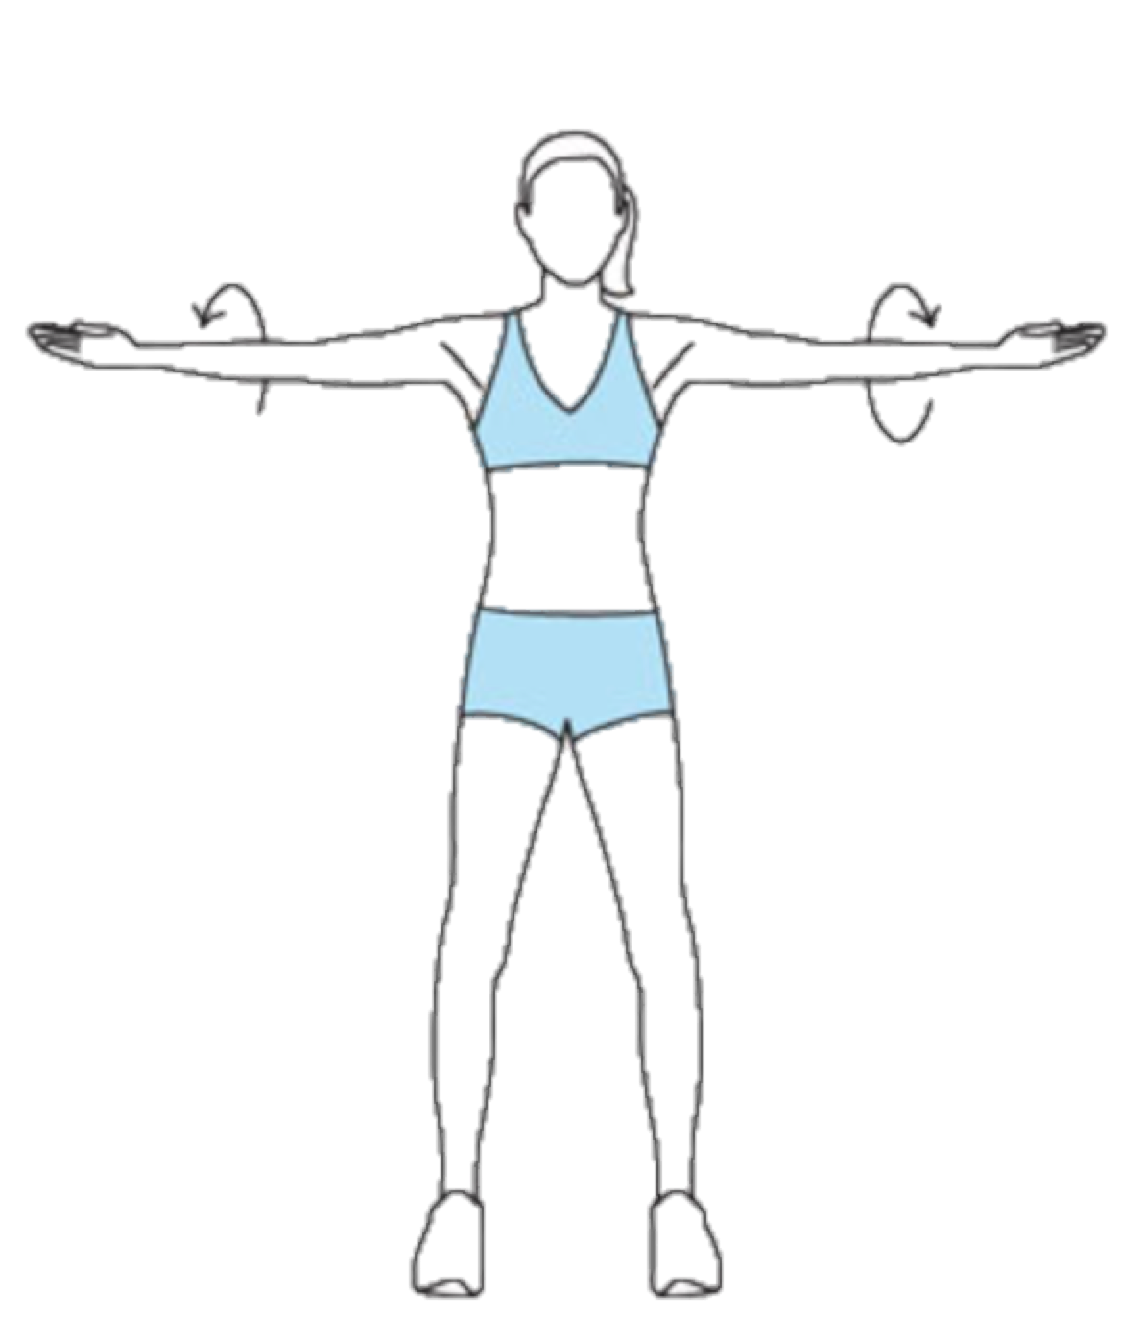
Level 3 | Push-ups  -Start with palms on floor underneath shoulders and knees straight.  -Slowly bend elbows out to side, lowering until just above floor.  -Push back up. Keep back and head in straight line.  3 sets of 5-10 reps |  | Tricep dips with knees bent  -Sit on edge of chair.  -Grip edge of seat and move body forward so feet are flat and legs are bent at 90 degrees.  -Slowly raise and lower body using triceps.  3 sets of 5-10 reps | 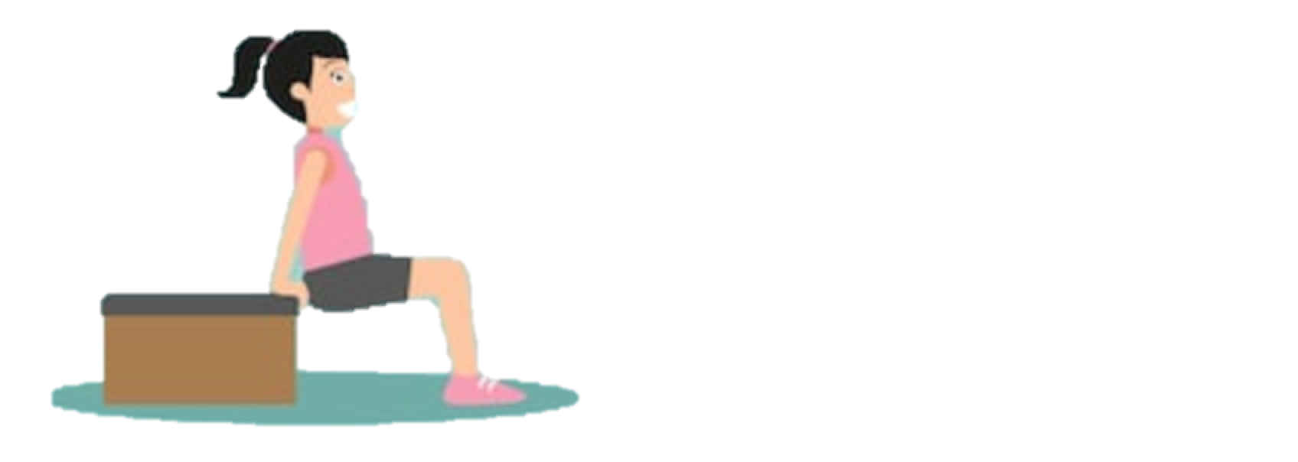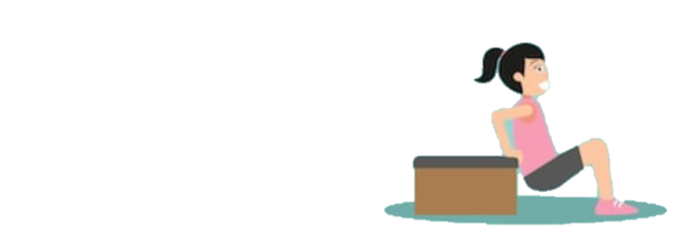
Level 4 | Decline Push-ups  Same as push-up, but elevate feet on a step.  3 sets of 5-10 reps |  | Tricep dips with legs straight  -Sit on edge of chair.  -Grip edge of seat and move body forward, stretching legs out straight so only heels are on ground.  -Slowly raise and lower body using triceps  3 sets of 5-10 reps
Strength Training: Core
These will help you get out of bed after surgery and do other activities, while preventing injuries.
Do one exercise from CORE A and one exercise from CORE B.
LEVEL | CORE A |  | CORE B
Level  1 | Static Hold  -Lie face up with legs in a tabletop position (knees bent 90 degrees and knees over your hips).  -Contract your core, pressing your low back into the ground.  -Place your hands on the front of your quads.  -Drive your quads into your hands while simultaneously pressing them away. There should be no visible movement in your body, but you should feel tension in your core. Count to 4, and release.  2 sets of 5 reps |  | Hip Bridge  -Lie on back with knees bent to 45 degrees.  -Slowly lift back and hips off floor  -Hold for 2 seconds, then lower back down slowly.  2 sets of 10 reps
Level 2 | Bird-dog  -Kneel with knees and feet hip-width apart. Place hands on floor, directly under shoulders.  -Extend your arm, lift opposite leg back, both straight. Keep hips squared.  -Place hand and leg back on floor.  2 sets of 5 reps on each side |  | Plank on knees  -Lie on stomach with forearms on floor, elbows directly underneath shoulders.  -Engage core, lift body off floor, keeping knees on floor. Keep back and neck in straight line.  3 sets of 30 seconds each
Level 3 | Bird-dog crunch  See instructions above for bird-dog.  -As you exhale, round your back as you bend your elbow and knee to bring them together.  -As you inhale, extend your arm forward and extend leg back.  2 sets of 5-10 reps on each side | 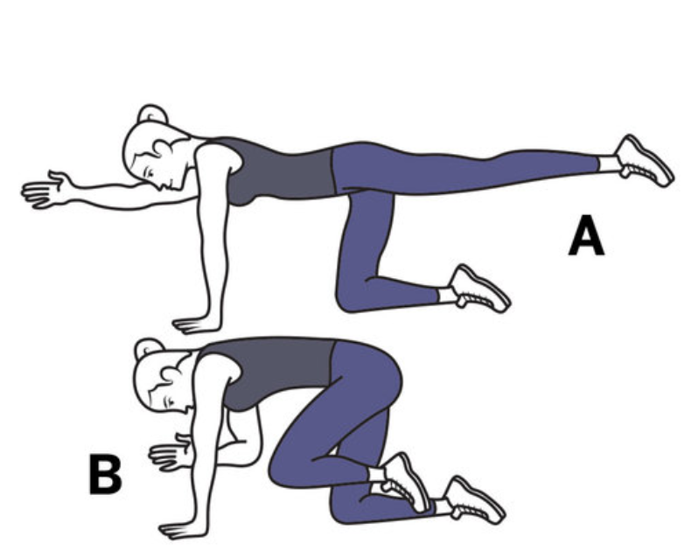 | Plank with legs straight  -Lie on your belly with forearms on floor, elbows directly underneath shoulders.  -Engage core and rise up on toes so only toes and forearms touch floor. Keep back and neck in straight line.  3 sets of 30 seconds each
Level 4 | Leg lifts  -Lie on back and lift legs to 90 degrees.  -Place both hands under your sacrum. Keep lower back pressed into the floor, and slowly lower legs to 45 degrees.  -Slowly bring legs back up, while keeping core engaged.  3 sets of 10-15 reps | 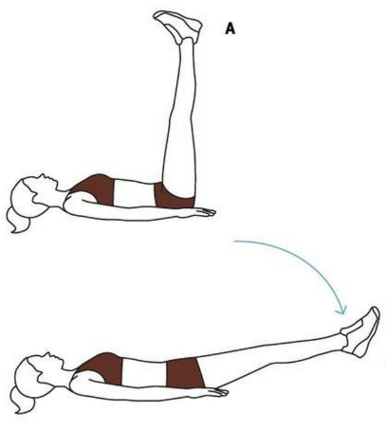 | Lateral plank taps  -Plank position with forearms on floor, elbows directly underneath shoulders.  -Slowly tap one foot out about 1 foot and bring back to center.  -Repeat with other foot.  3 sets of 10-15 reps

Strength Training: Balance
These integrate core, glute and leg strength. Hold each position for 3-5 seconds.
Do one exercise from BALANCE A and one exercise from BALANCE B.
LEVEL | BALANCE A |  | BALANCE B
Level  1 | Bend leg back with support  -Stand with hands on wall or other support.  -Bend one knee 90° to bring foot behind you, while balancing on the other leg.  2 sets of 10 reps on each side | 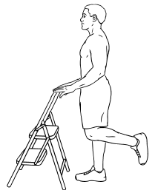 | Bend knee to chest with support  -Stand with one hand on wall or table for support.  -Bend one knee while lifting leg towards the chest.  -Slowly lower back down to the ground.  2 sets of 10 reps on each side |  | 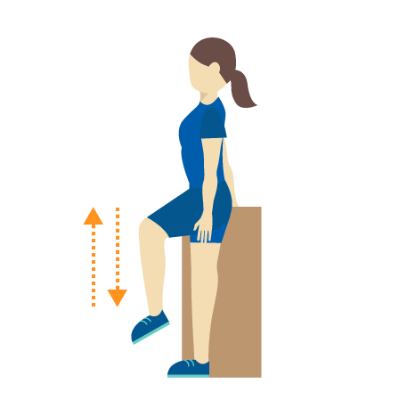
Level 2 | Bend leg back without support  -Start in standing position.  -Bend one knee 90° to bring foot behind you, while balancing on the other leg.  2 sets of 10 reps on each side | 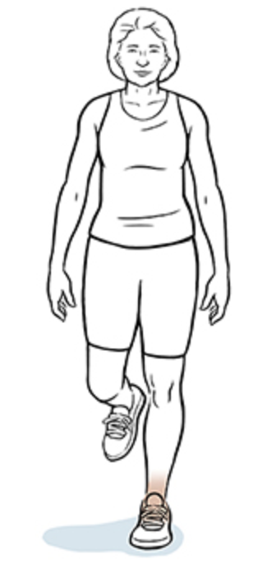 | Bend knee to chest without support  -Start in standing position.  -Bend one knee while lifting leg towards the chest  -Slowly lower back down to the ground.  2 sets of 10 reps on each side |  | 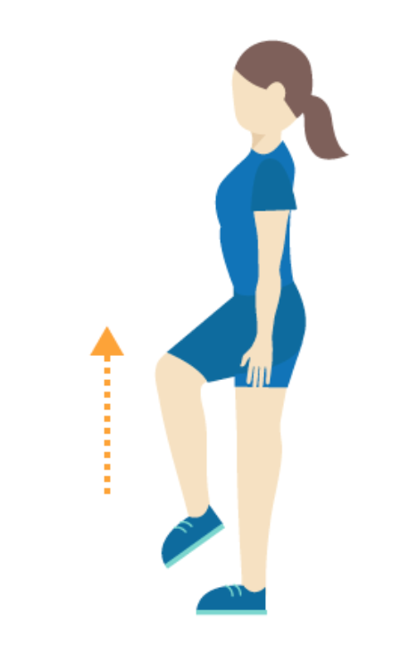
Level 3 | Standing leg circles  -Start in standing position. Lift one leg, bending the knee to 90 degrees.  -Slowly circle the leg at the hip joint 5 times counterclockwise and 5 times clockwise  -Make sure a support is nearby.  2 sets of 10 reps on each side |  | Warrior III with support  -Stand with one hand on wall or table for support.  -Lean chest forward and lift one leg off the ground, keeping the lifted leg straight.  -Keep soft bend in the standing knee.  -Slowly return to standing on both feet.  2 sets of 10 reps on each side |  | 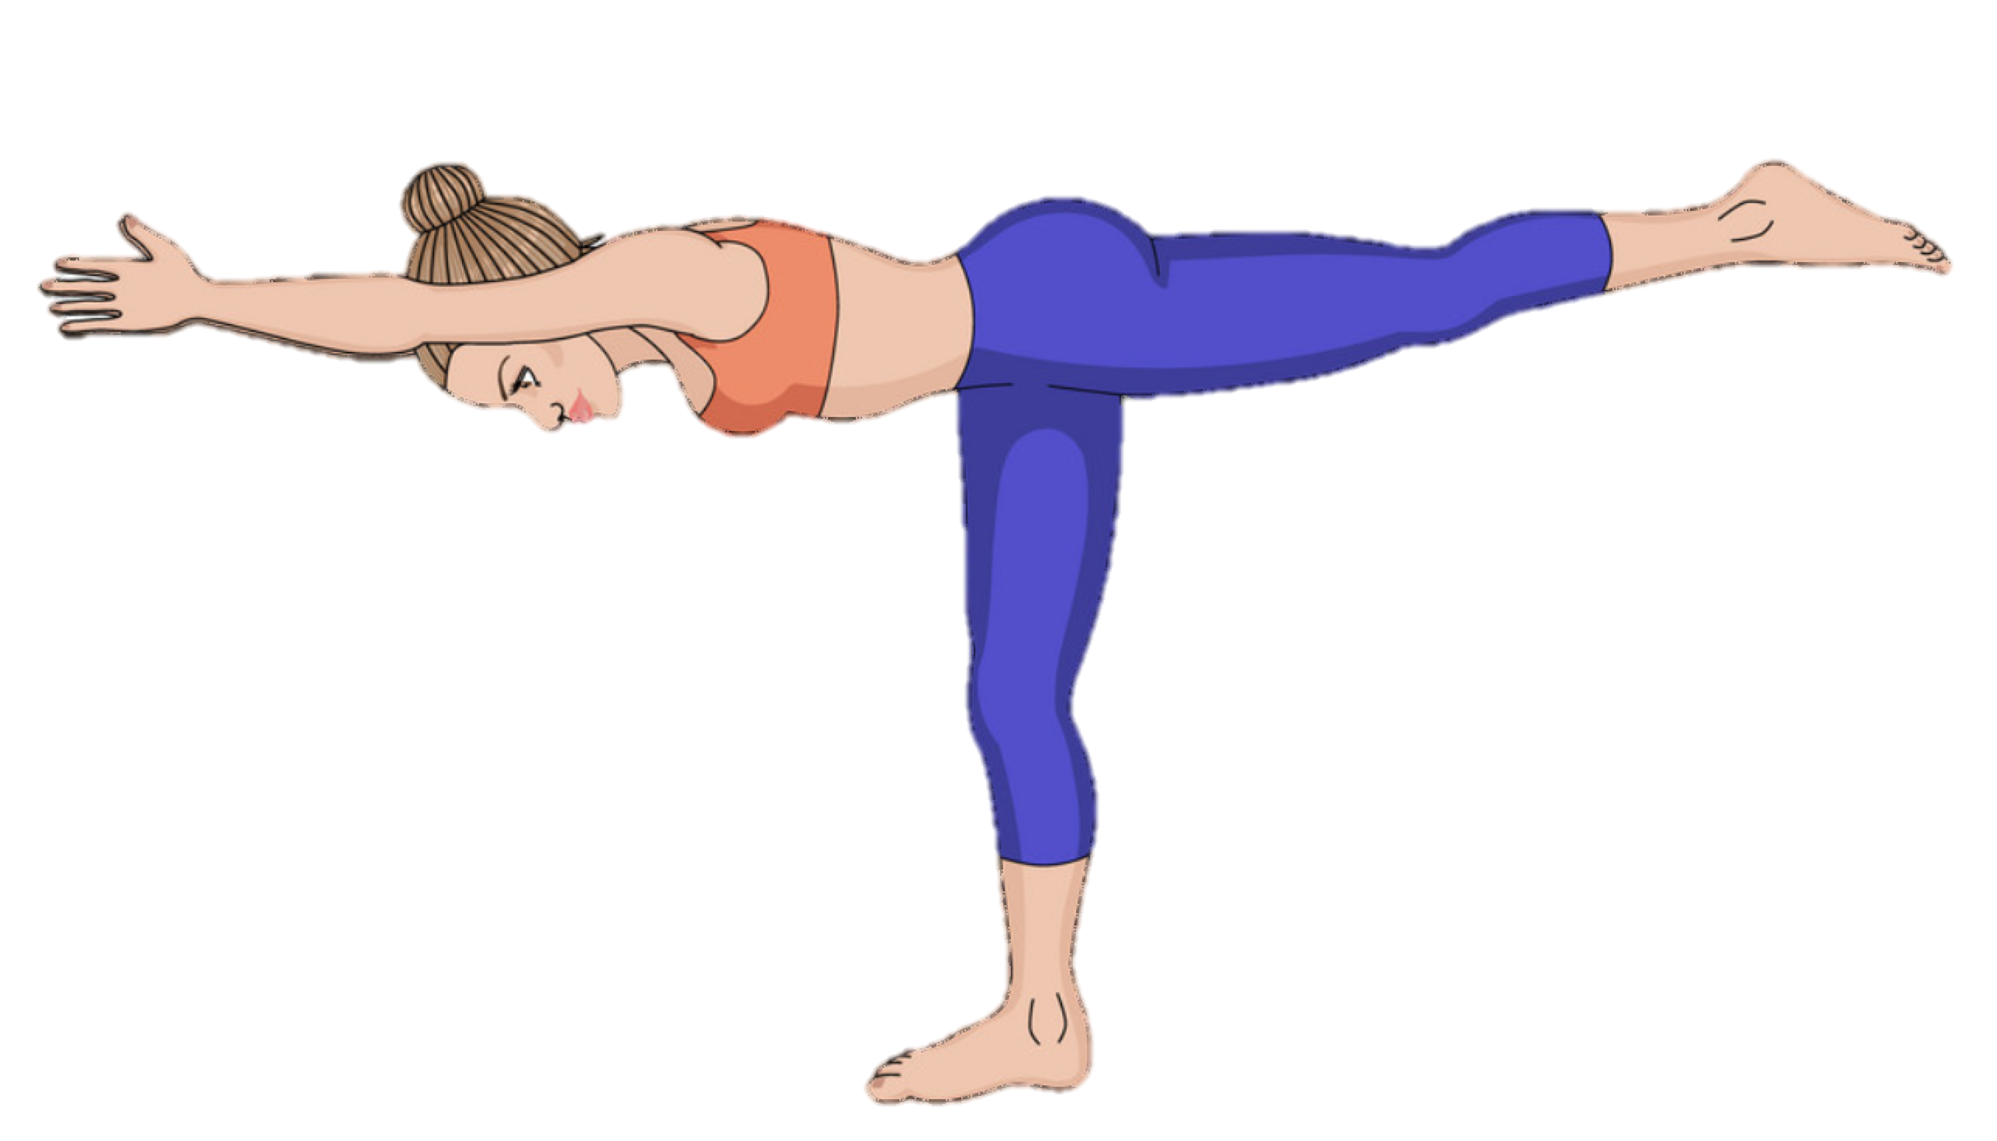
Level 4 | Standing leg circles, eyes closed  - Lift one leg, bending the knee to 90 degrees. Close your eyes.  -Slowly circle the leg at the hip joint 5 times counterclockwise and 5 times clockwise  -Make sure a support is nearby.  2 sets of 10 reps on each side |  | Warrior III without support  -Start in standing position.  -Lean chest forward and lift one leg off the ground, keeping the lifted leg straight.  -Keep soft bend in the standing knee.  -Slowly return to standing on both feet.  2 sets of 10 reps on each side
Stretches
Stretching will help you stay limber before and after surgery. Do 3 different stretches at least once a week.
Before stretching, warm up with walking, jogging or biking for at least 5 minutes. Or, stretch after you do your cardio or strength exercises.
Cat/cow:stretches spine  -Start with your palms and knees on the floor. Hands are under shoulders. Knees are under hips.  -As you inhale, drop the belly, squeeze the shoulder blades together and look up, tilt the hips up.  -As you exhale, tuck your hips under, round the upper back and tuck chin to chest. Repeat 10 times. |  |  |  | 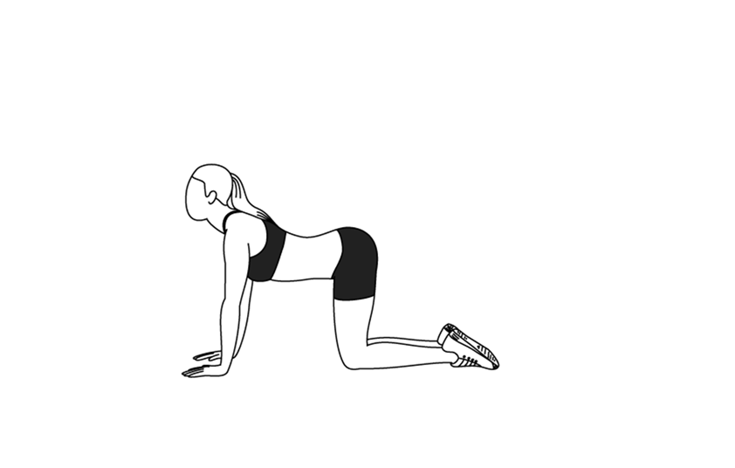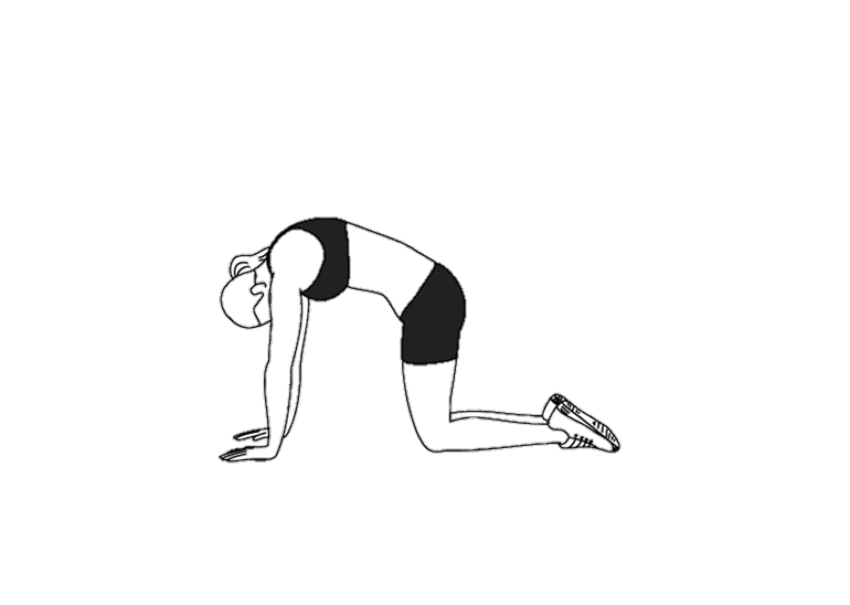
Standing side bend: stretches sides  -Start standing. Grasp left forearm with right hand and lean to the right. Keep your left foot down.  -You should feel a stretch on the left side.  -Come back to center position, switch hand grip and repeat on other side. Do this 5-10 times. |  |  |  | 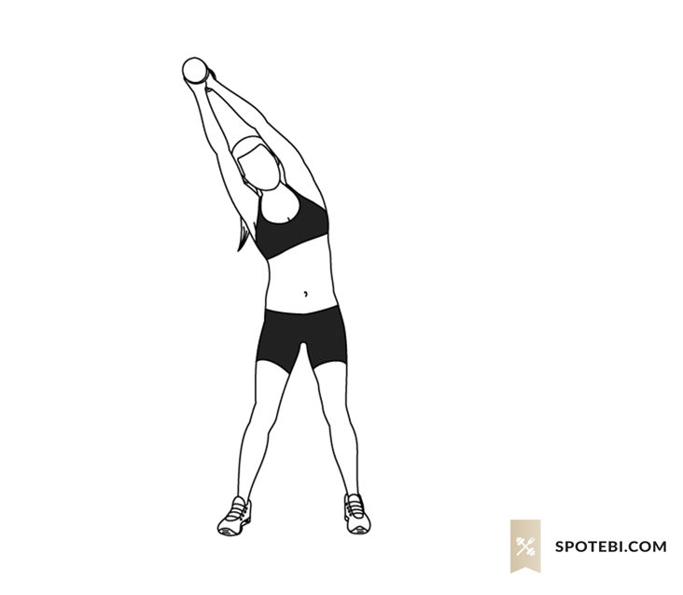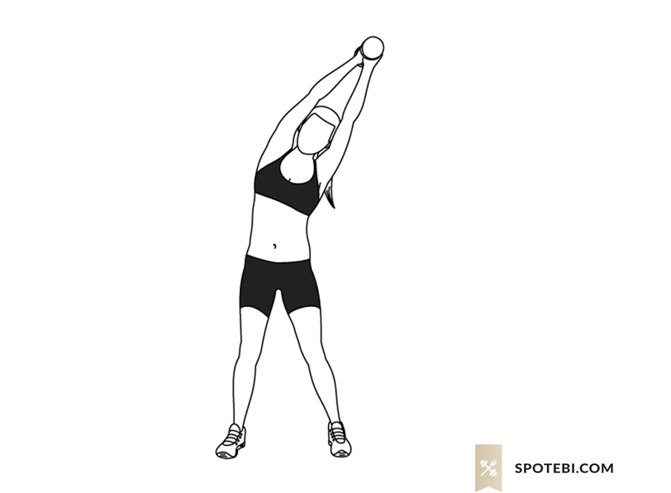
Chest stretch with arm on wall: stretches front of shoulder  -Stand with chest against wall. Extend one arm out on the wall, parallel to the ground.  -Turn the chest so that the body is now perpendicular with the wall and the arm is extended behind you, still pressed up against the wall. Repeat on the other side. |  |  |  | 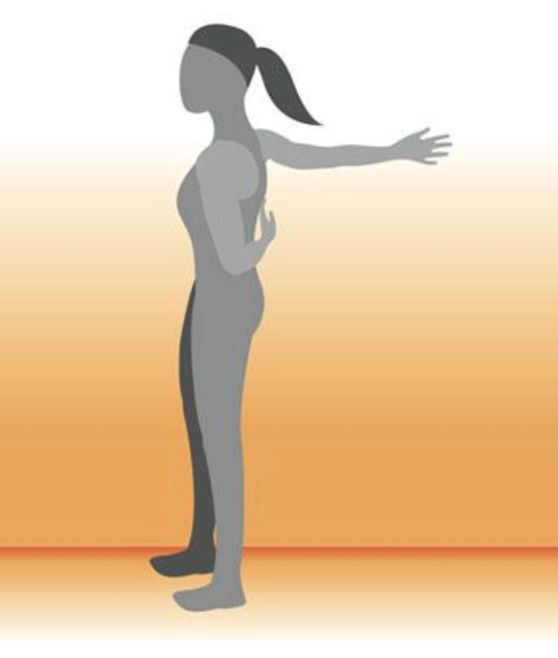
Lateral reach-through: stretches back of shoulder  -Start on all fours. Cross right arm across chest and between the left arm and thigh. Bend your left elbow as you lean into your right side. You should feel a stretch in the back of the right shoulder.  -Hold for 15-30 seconds and return to the starting position. Repeat 2-4 times on each side. |  |  |  | 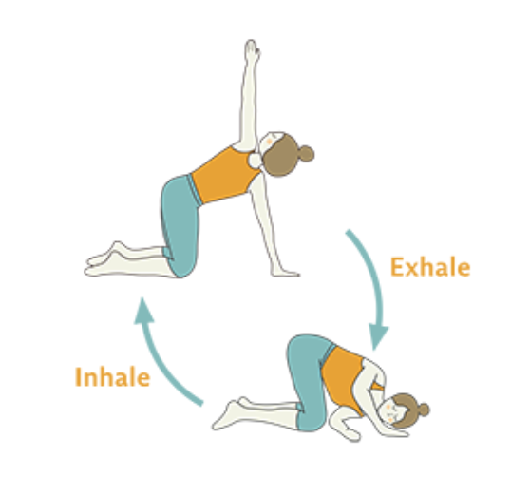
Butterfly: stretches inner thighs and quads  -Sit with knees bent and soles together.  -Depending on flexibility, the feet will be away or close to the hips.  -As the knees reach for the floor, keep the chest lifted. Hold for 15-30 seconds, repeat 2-4 times. |  |  |  | 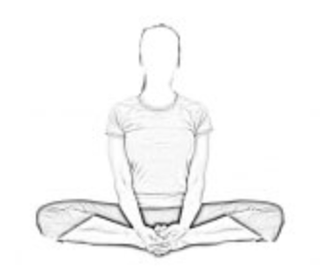
Seated forward fold: stretches hamstrings and low back.  -Sit with your legs together and extended.  -Reach arms up overhead and lean forward reaching for the feet.  -If hands do not reach the feet, wrap towel or strap around the feet. Pull the feet towards the torso. |  |  |  | 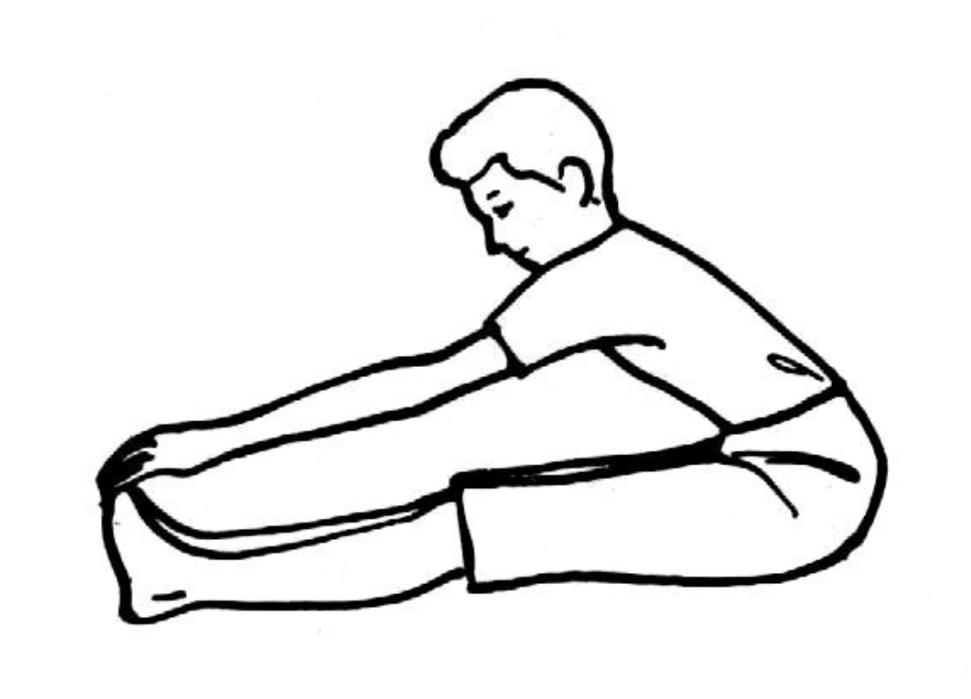
Flexed foot on the step: stretches calf  -Stand on a stable step with one hand on the wall for support.  -Move one foot back so that the ball is on the step and the heel is off the step.  -Lower the heel toward the ground while bending the other knee.  -Hold for 15-30 seconds and repeat on the other side. Do this 2-4 times. |  |  |  | 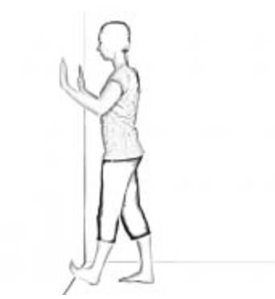
Cardio
Do either HIIT or lower-intensity cardio every other day. You can walk, jog, or run, or use a stationary bike or rowing machine.
LEVEL | High-Intensity Interval Training (HIIT) |  |  |  |  | Lower-Intensity Cardio
Level  1 | ~10 minutes  -Warm up for 3 minutes at a pace where you can speak in full sentences.  -Pick up the pace for 20 seconds, working hard enough where you are too winded to speak.  -Slow down to easy pace for 2 minutes.  -Repeat two more times (fast pace for 20 seconds, and easy pace for 2 minutes).  -Cool down for 2 minutes at easy pace. |  |  |  |  | 15 minutes jog or walk
Level 2 | ~35 minutes  -Warm up for 3 minutes at an easy pace.  -Pick up the pace for as fast as you can go for 4 minutes without feeling a burning sensation,  but hard enough so you are slightly uncomfortable.  -Return to easy pace for 3 minutes.  -Repeat 3 more times (fast pace for 4 minutes, and easy pace for 3 minutes)  -Cool down for 5 minutes at easy pace. |  |  |  |  | 25 minutes jog or walk
Level 3 | ~35 minutes  -Warm up for 5 minutes at an easy pace.  -Pick up the pace, giving maximum effort for 30 seconds  -Recover with light effort for 4.5 minutes  -Repeat 4 more times.  -Cool down for 5 minutes at original pace. |  |  |  |  | 35 minutes jog or walk
Level 4 | ~25 minutes  Warm up for 5 minutes at an easy pace.  Pick up the pace, giving maximum effort for 30 seconds  Recover with light effort for 2 minutes.  Repeat 6 more times.  Cool down for 5 minutes at original pace. |  |  |  |  | 45 minutes jog or walk

